
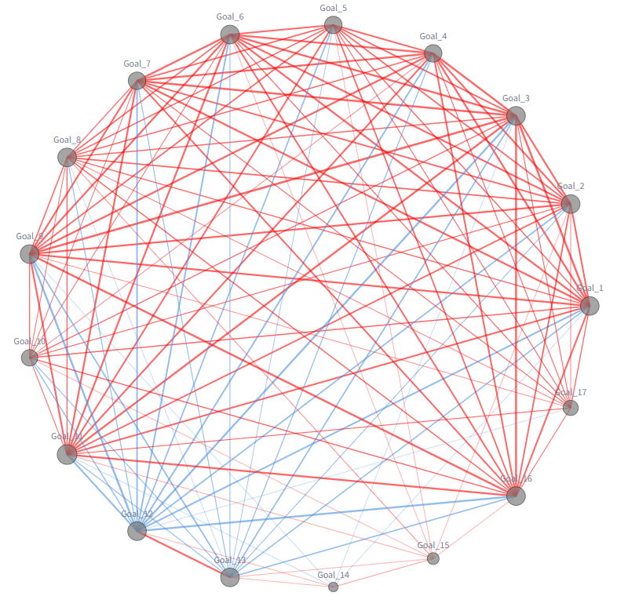
The Global SDG Landscape: Performance, Momentum, and Structural Links
Jesus Eric Seacor (24007226), Sai Ram Ceka (24011574)
Course: 158.888 Information Technology Professional Project

Teaching Team: Dr. Anuradha Mathrani, Dr. Niloofar Aflaki
Due Date: 20th October 2025

Table of Contents
1 Executive Summary 1
2 Introduction 2
2.1 Project objectives 2
2.2 Research Questions 2
2.3 Purpose and audience 3
3 Background and related work 4
3.1 SDG measurement landscape. 4
3.2 Interlinkages: synergies and trade-offs. 4
3.3 Technological Approaches to Data Handling 4
3.4 Classifications of SDG Goals 4
3.5 Methods used in the literature 6
3.6 Where this project fits 7
4 Methodology 7
4.1 Data sources and structure 7
4.2 Cleaning & integration 8
4.2.1 Generated result datasets 8
4.3 Verification against SDR Dashboards (rankings & explorer) 9
4.4 System implementation 10
4.4.1 GoalScope SDG Analytics Hub (Seacor, 2025) 10
4.4.2 SDG Predictions App (Ceka, 2025) 11
4.5 Challenges encountered and how we resolved them 11
4.5.1 GoalScope SDG Analytics Hub (Seacor, 2025) 11
4.5.2 SDG Predictions App (Ceka, 2025) 12
5 Findings by Research Questions 13
5.1 Global snapshot (2025) 13
5.1.1 What is the current world average status and trajectory vs 2030 targets? 13
5.1.2 Which regions lead and which lag on the overall score in 2025? 14
5.2 Change & momentum 16
5.2.1 Which SDG goals account for the largest positive change between 2015 and 2025, and which goals show stagnation or decline, based on % change in the goal index? 16
5.2.2 Which countries improved the most—and which slipped—on the Overall SDG Index between 2015 and 2025, and what patterns by region and starting level emerge? 17
5.2.3 Within the OECD, do any members show downward trends in specific goals? 18
5.3 Regional gaps & dispersion 21
5.3.1 Across Africa, which countries are the SDG “leaders”, “emerging improvers”, “stable/slipping” and “laggards” when we consider both level (end-year score) and momentum (% change over 2015→2025)? 21
5.4 Inter-goal links & trade-offs 22
5.4.1 In the 2025 global network of SDG goal scores, which goals are central “synergy hubs,” which are peripheral, and where are the main trade-offs? 22
5.4.2 What latent structure organizes cross-country SDG performance in 2025, and which goals align with—or run counter to—the dominant development axis? 24
5.4.3 Which goals are most strongly linked with the Overall score in 2025? 25
5.4.4 Which goal pairs move together the most and which show trade-offs in 2025? 25
5.5 Where does New Zealand stand on the SDGs in 2025, which goals are lagging, and what cross-goal linkages (synergies/trade-offs) explain those gaps—so where should policy focus to accelerate progress to 2030? 26
5.5.1 Overall Standing, Rank, and Goal-Level Imbalances (2025) 27
5.5.2 Status & momentum: NZ’s overall score/rank in 2025 and % change over 2015→2025; goal-by-goal trend lines to flag any downward or flat goals. 28
5.5.3 Gap analysis: Distance (points and %) from the OECD top-quartile for each goal, highlighting the few goals that dominate the shortfall. 29
5.5.4 Structure & drivers: Which goal bundles in New Zealand move together from 2015 to 2025 and where do the main tradeoffs sit, so what two or three policy packages would deliver the biggest co benefits by 2030? 30
5.5.5 New Zealand overall score forecast to 2030 31
5.5.6 Forecasting New Zealand vs OECD on SDG 8 (Unemployment 2026 – 2030) 32
5.5.7 Forecasting New Zealand’s Goal 3 and Goal 13 (2026–2030) 33
5.6 Synthesis 34
5.6.1 Actionable policy bundles 35
5.6.2 Country lens (New Zealand) 35
5.6.3 Overall message 35
6 Discussion 35
6.1 Overview of patterns 35
6.2 Policy implications 36
6.3 Reading change correctly 36
6.4 Strengths and limitations 36
6.5 Implications 36
7 Conclusion 37
8 Future Work 37
8.1 GoalScope SDG Analytics Hub (Seacor, 2025) 37
8.2 SDG Predictions App (Ceka, 2025) 38
9 Personal learning 39
10 References 40

Executive Summary
The 2030 Agenda spans 17 interlinked Sustainable Development Goals (SDGs) that must advance together. This project analyzes global SDG indicators to reveal the levels, momentum, and inter-goal linkages that matter for policy. We combined cross-country time series with correlation/PCA-based analysis and generated NLP dynamic insights to support interpretation. The outcome is an interactive analytics framework and Python module for reproducible SDG assessments and projections.
Key Findings:
- 2025 global snapshot. Regions are uneven: the OECD leads (79.70), E. Europe & C. Asia follow (73.71), and Africa is lowest (56.39)—a 23.31-point spread.
- Where the momentum came from (2015→2025): The largest lift is SDG 9 (+25.84%), SDG 12 has the strongest negative link to SDG 9 (r=-0.85); SDG 16 has the most decline (−4.80%).
- OECD profile. Within the OECD, SDG 16 (−3.16%) and SDG 2 (−2.19%) fall over the decade; movement elsewhere is modest, led by SDG 9/5/17.
- New Zealand’s performance is imbalanced: a huge portion of its shortfall comes from environmental goals.
- Africa: level vs momentum. Despite the lowest average, Africa shows leaders above the median and an “emerging” band rising quickly (e.g., Benin +17.6%, Guinea-Bissau +15.5%, Togo +14.5%).
- Inter-goal links & trade-offs. The SDG system forms a dense socio-economic core (hubs: SDGs 3, 9, 4, 6, 1). The sharpest trade-offs centre on SDG 12, including 12–9 (r=−0.85), 12–3 (r=−0.80), 12–16 (r=−0.80).
Implications:
Priorities differ by context. For high performers (e.g., OECD), marginal gains come from circular economy and nature-positive investment (SDGs 12, 14–15, 2/17 as enablers). For lower-income contexts, closing foundational gaps (SDGs 1–6, 10) unlocks system-wide progress, while selectively scaling innovation and infrastructure (SDG 9) sustains momentum. Together, GoalScope’s evidence and tooling provide a practical basis for targeted, non-piecemeal progress to 2030.

Introduction
The SDG progress must be coordinated because advances in one area can amplify—or undermine—others. That principle of indivisibility and the risk of trade-offs motivate transparent measurement and analysis to guide policy design (e.g., International Council for Science, 2017; Breuer et al., 2022; Niklasson, 2019; Barbier & Burgess, 2021). This project contributes a reproducible, data-driven workflow and an interactive application—GoalScope—that converts authoritative, open SDG data into decision-ready evidence and a separate Streamlit SDG Predictions App dedicated to short horizon predictions. GoalScope is a Streamlit front-end over a reusable Python module that performs all data acquisition, cleaning, and analytics. All data analysis figures and plots in this report were generated directly by GoalScope, ensuring results are reproducible from the same code and data version. Data is programmatically sourced via API from two authoritative feeds: UN SDG endpoints and Sustainable Development Report (SDR) ArcGIS layers. The resulting clean datasets, maintained on the familiar 0–100 index scale, underpin all ranking, timeline, correlation, and short-horizon projection views presented here.

Project objectives
The core project objectives were to:
- Build a clean, auditable SDG dataset and lookup table suitable for advanced analysis.
- Implement robust visual analytics routines, including ranking, timelines, correlations, and short-term projections.
- Compare index-based change metrics with the world-raw change methods common in academic literature.
- Produce the application for interactive data exploration and reporting with NLP and forecasting features.
- Document the data feeds, methodologies, and limitations clearly.

Research Questions
This study is organised into five linked research branches. Each branch frames a set of focused sub-questions that are answered in the Findings (Sections 5.1–5.5) using the corresponding GoalScope analytic views.
- 2025 Snapshot — Who leads/lags by region, country and goal?
- Change & Momentum — How fast did scores move from 2015–2025, and where are the stalls or declines?
- Regional Gaps & Dispersion — How wide are within-region differences (e.g., Africa) and which patterns matter?
- Inter-Goal Structure — Where are the synergies and trade-offs among goals (correlations, network, PCA)?
- Focused New Zealand Assessment — Where NZ stands, what lags, and which cross-goal linkages explain the gaps.
Each question is paired with an analytic view in the GoalScope application, allowing the reader to trace findings back to the underlying methods and data. In essence, this report is a working showcase of the GoalScope system: a compact, auditable system that delivers consistent visual answers to SDG questions across all levels (world, region, country) and all 17 goals.

Purpose and audience
The core purpose of analyzing Sustainable Development Goal (SDG) correlations and regional trends is to advance coherent and integrated decision-making by systematically uncovering the complex interdependencies, particularly identifying synergies and trade-offs, among the goals (Breuer et al., 2022). This analysis translates complex scientific evidence into actionable insights used by institutions to set priorities, effectively allocate resources, and develop streamlined policies across the economic, social, and environmental dimension.
The extensive audience for this project includes:
- Policymakers and Government Entities: Who rely on the data for policy design, implementation, and accountability enhancement.
- Researchers and Academics: Who utilize the analysis for advancing conceptual models and assessing various SDG methodologies.
- The Private Sector and Investors: Who rely on regional performance metrics for strategic planning, risk assessment, and investment alignment.
- Civil Society Organizations and the Public: Who gain the transparency and knowledge necessary to assess sustainability challenges and hold stakeholders accountable.

Background and related work

SDG measurement landscape.
The SDG Index and Dashboards compile many indicators into 0–100 goal scores and an overall score, updated annually. The intent is comparability across countries/years, but the index inevitably compresses diverse indicators into a single scale. Governance and implementation challenges in turning global goals into practice are well documented (Niklasson, 2019) and continue to motivate empirical, decision-support work (Swain & Dobers, 2025).

Interlinkages: synergies and trade-offs.
A core theme in the SDG literature is that goals interact. The science-policy guide on SDG interactions formalised a structured way to think about co-benefits and trade-offs across goals and targets (International Council for Science, 2017), and more recent work surveys governance approaches to manage those interlinkages (Breuer et al., 2022). Sector studies (e.g., sanitation) find wide evidence of synergies with most goals and trade-offs with a smaller subset, highlighting that design and context matter (Parikh et al., 2021). From an economics angle, policy mixes need to align institutions and incentives to avoid “grow now, fix later” dynamics (Barbier & Burgess, 2021).

Technological Approaches to Data Handling
Advanced SDG scholarship now leans on NLP and AI to digest massive text corpora and surface cross-goal linkages at scale. The Routledge Handbook of the UN SDGs Research and Policy documents end-to-end NLP pipelines—query design, text pre-processing, n-gram extraction, co-occurrence analysis, and network visualization—to map Water–Energy–Food–SDG interlinkages from thousands of records, and it reports AI-assisted text mining of UN Voluntary National Reviews and Universal Periodic Reviews using supervised classifiers that tag passages to SDG targets, rights themes, and affected groups (Swain & Dobers, 2025).

Classifications of SDG Goals
The SDGs were established to provide a detailed framework for intergovernmental policy efforts and public engagement towards a more sustainable future. However, there is no single, consensual view on which specific SDG goal belongs to which dimension. The goals are broadly described and often cover multiple, sometimes dispersed, aspects, making a clear-cut classification challenging. The interconnectedness of the three dimensions means that efforts to improve one may impact the others, positively or negatively (Gehringer & Kowalski, 2023).
SDG goal groupings: Barbier & Burgess and the Wedding Cake model
Barbier & Burgess Classification (2017) | Stockholm Resilience Centre’s Wedding Cake (2016)
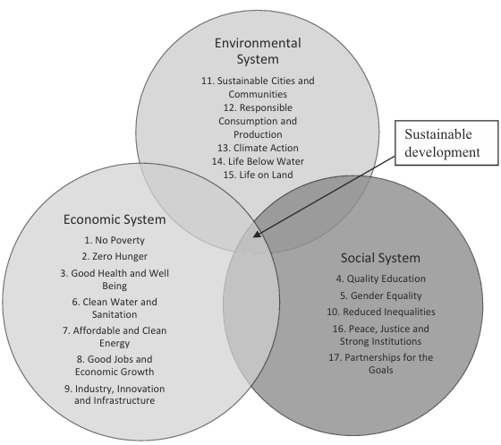 | 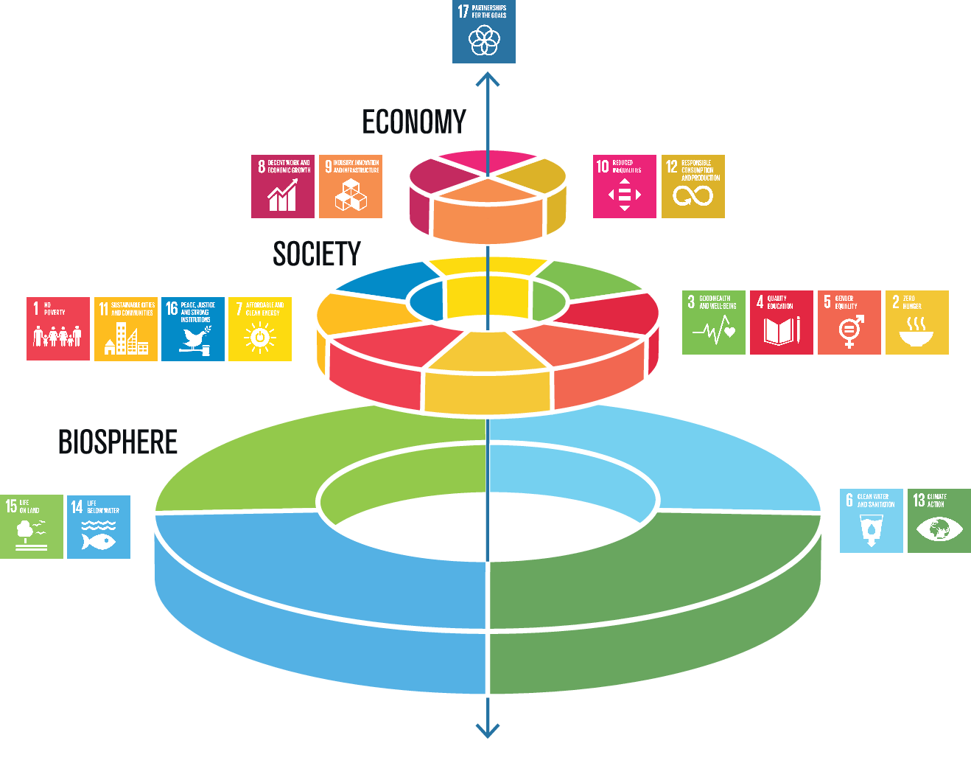

To make interaction patterns tractable, researchers often group goals into social, economic, environmental, and partnership/institutional pillars (e.g., Stockholm Resilience Centre’s “wedding cake” heuristics, or classifications discussed by Barbier & Burgess, 2021). Using grouped views alongside per-goal results helps detect whether co-movement is really a broad pillar effect or just a couple of dominant goals.
Several approaches have been developed to classify the 17 SDGs:
- "Wedding Cake" Conceptualization (Stockholm Resilience Centre, 2016): This model suggests a hierarchical relationship where economies are embedded in societies, and societies are embedded in the biosphere.
  - Biosphere Layer: SDGs 6, 13, 14, 15
  - Society Layer: SDGs 1, 2, 3, 4, 5, 7, 11, 16
  - Economy Layer: SDGs 8, 9, 10, 12
  - Partnerships: SDG 17
- Barbier and Burgess (2017) Classification: This approach explicitly designates each SDG as primarily an economic, environmental, or social system goal, forming the foundation for their economic analysis. They acknowledge that this assignment is somewhat arbitrary and that some SDGs may overlap.
  - Economic System Goals: SDGs 1, 2, 3, 6, 7, 8, 9
  - Environmental System Goals: SDGs 11, 12, 13, 14, 15
  - Social System Goals: SDGs 4, 5, 10, 16, 17
- Gehringer and Kowalski's Own Classification (Gehringer & Kowalski, 2023): Based on a bottom-up methodology, reviewing all 169 targets and 231 indicators of the SDGs, identifying the prevailing dimension for each SDG. SDG 17 is treated as an all-embracing goal without a clear classification to only one dimension.
  - Social Dimension: SDGs 1, 2, 3, 4, 5, 6, 10, 11, 13, 16.
  - Economic Dimension: SDGs 7, 8, 9.
  - Environmental Dimension: SDGs 14, 15.
- Other Approaches (Boar, Bastida, & Marimon, 2020) (e.g., Boar et al., Dangelmaier):
  - Unanimously Classified SDGs (across Boar et al., Dangelmaier, and Barbier & Burgess):
    - Social: SDG 5 (Gender Equality)
    - Environmental: SDG 14 (Life Below Water), SDG 15 (Life on Land)
  - Boar, Bastida, and Marimon (2020): Social (SDGs 1-5, 7, 11, 16), Environmental (SDGs 6, 13-15), Economic (SDGs 8-10, 12). SDG 17 is "Partnership to Achieve the Goals".
  - Dangelmaier (2022): Places SDG 10 (Reduced Inequality) in the social dimension (unlike Boar et al.). Also introduces "climate" as a sub-dimension of environmental and "governance" as an additional dimension. Identifies confluent areas where SDGs belong to more than one dimension, e.g., SDGs 6, 7, 11, 12 in both social and environmental dimensions, and SDGs 4, 8 in both social and economic dimensions.

Methods used in the literature
Typical empirical tools include correlation matrices, principal component analysis (PCA) to uncover alignment across goals/countries, and network/interaction scoring frameworks. Importantly, correlation ≠ causation: co-movement may reflect income, institutions, or shared shocks. For change over time, Barbier and Burgess (2021) compute world-level change from raw indicators (with direction correction and sometimes population weights); this is not the same as % change on the index scale. Both routes are informative but answer different questions—hence we implement both in Methods to keep results comparable to the literature.

Where this project fits
This study contributes a transparent, reproducible pipeline and app: comparable level and %-change views for Overall and each goal; region/country lenses, including dispersion within regions; grouped correlations to visualise alignment vs. trade-offs; and a discussion that keeps policy-relevant interpretation front-and-centre (e.g., when “basic services” goals move together while some environmental/consumption goals do not). The aim is to turn desk research into an interactive tool students, researchers and policy analysts can reuse.

Methodology
We designed and delivered an end-to-end SDG analytics system that turns authoritative, open data into reproducible, interactive evidence. The system comprises: Two companion applications. We built GoalScope, our primary analytics and visualisation app for rankings, timelines, structure and correlations with NLP generated insights and chatbot assistant (Seacor, 2025); and a separate SDG Predictions App dedicated to short-horizon projections (Ceka, 2025). Both apps read the same prepared datasets to ensure a single source of truth.
A scripted data pipeline: We programmatically acquire SDG data from UN SDG endpoints and Sustainable Development Report (SDR) ArcGIS layers, harmonise fields, and produce two canonical tables that drive every analysis and figure.
Reproducibility by construction: All figures and plots used to answer the research questions are generated directly by GoalScope and the SDG Predictions App from the same code and data version.

Data sources and structure
We combined two authoritative sources via API:
- Programmatically pulled the official SDG goal catalogue from the UN SDG API (/SDGAPI/v1/sdg/Goal/List), parsed the JSON to a pandas DataFrame, and kept the fields code, title, description for use as the canonical Goal lookup.
- Retrieved the SDR datasets (Codebook, Backdated Time-series, 2025 with indicators) directly from ArcGIS Online FeatureServer layer 0. A small wrapper maps dataset ∈ {codebook, sdr_backdated, sdr2025, rawdata} to the correct service URL, then pages through results using resultOffset/resultRecordCount (page size 2,000) until no features remain (where = 1=1). We request JSON (f=json), suppress geometry, and extract the attributes from each batch into a pandas DataFrame. This yields canonical tables for indicators/metadata (codebook) and harmonized time-series used throughout the analysis.

Cleaning & integration
We construct a unified SDG panel by joining a canonical lookup to cleaned SDR time-series. First, we derive a goals_lookup (Goal_1…Goal_17) with group tags, then merge it with a slimmed SDR Codebook (IndCode, SDG, Indicator) to create df_lookup (code, sdg, group, description). Next, we standardise the Backdated timeseries: drop null indexreg_, normalise column names (e.g., Goal_*, remove n_ prefixes), and retain ID/country/year plus SDG/region fields. We similarly reshape SDR 2025 (strip _Score, fix _Score_reg naming), align keys (ID, Country, Region), and insert Year=2025. Finally, we row-bind backdated and 2025 tables, sort by Country, Year, cast SDG columns to numeric with coercion, and harmonise region labels (e.g., ‘E. Europe & C. Asia’ → ‘E_Euro_Asia’). This yields df_sdg for analysis and df_lookup for consistent titles/legends/tooltips

Generated result datasets
- df_sdg — Canonical country–year panel of SDG index scores (2000–2025). One row per Country–Year; columns include Country, Year, Region, goal-level indices Goal_1…Goal_17 on a 0–100 scale, plus selected sdg_* indicator fields. Built from UN SDG/SDR ArcGIS timeseries, then standardised to tidy numeric types, harmonised country/region names, and clipped to 0–100. Designed to join to df_lookup and used for rankings, timelines, correlations, and short-term forecasts.
- df_lookup — Compact catalogue of SDG codes with numeric sdg (1–17), human-readable title/description, and a coarse group label (economic / social / environmental / partnership). Created by combining the UN goals list with the SDR codebook, then mapping each SDG to a group. A helper supports alternative groupings (e.g., Barbier & Burgess; Stockholm Resilience “Wedding Cake”). Drives labels, legends, and grouping options across all plots.

Verification against SDR Dashboards (rankings & explorer)
To verify the correctness of our data summarisation and computations, we cross-checked GoalScope outputs against the public SDG Index dashboards—the Rankings view and the Data Explorer view:
- Rankings: https://dashboards.sdgindex.org/rankings
- Data Explorer: https://dashboards.sdgindex.org/explorer/
Because our canonical panel and 2025 snapshot are built from the UN SDG API and SDR ArcGIS layers, the SDR dashboards are the appropriate external reference for both the 2025 SDG values and the backdated time-series that underpin our charts.
Procedure:
- Replicate filters. We matched dashboard filters (year = 2025; same region labels) and applied identical country inclusion rules. (Region harmonisation was already part of our cleaning step.)
- Rank order check (overall). We compared top/bottom lists and full rank order to the Rankings dashboard. Any discrepancies were traced to imputation and rounding.
- Goal-level spot checks (Explorer). For a rotating sample of countries across regions and performance tiers, we verified goal profiles and trend lines against Explorer, ensuring our 0–100 goal indices and trajectories aligned visually and numerically.
- Chart-to-chart parity. We validated our regional ordering, country trajectories, and goal correlation patterns by inspecting dashboard values for the same entities/years used in our figures.
Discrepancy handling: During early checks, some country ranks did not match the Rankings dashboard. We found SDR falls back to the regional goal score when a country’s goal value is missing; our first pass treated missing values as NA, biasing the overall mean. We implemented the same regional fallback in our pipeline and recomputed the overall index/ranks; after alignment, our lists matched SDR under identical filters.
Outcome: After filter and imputation alignment, GoalScope’s ranks, 2025 goal profiles, and time-series were consistent with the SDR dashboards, with only expected minor rounding differences from on-screen formatting. This provides an external verification baseline for all ranking and chart views generated from our single source-of-truth datasets.

System implementation
We provide links rather than embedding code; full code base is available in the GitHub repository.

GoalScope SDG Analytics Hub (Seacor, 2025)
GoalScope is a thin Streamlit UI over a reusable Python analytics module. The module handles data acquisition/cleaning, produces canonical frames, and serves complete data analysis that generate every figure in this report. The UI simply passes user inputs to these routines and renders the returned Plotly figures.
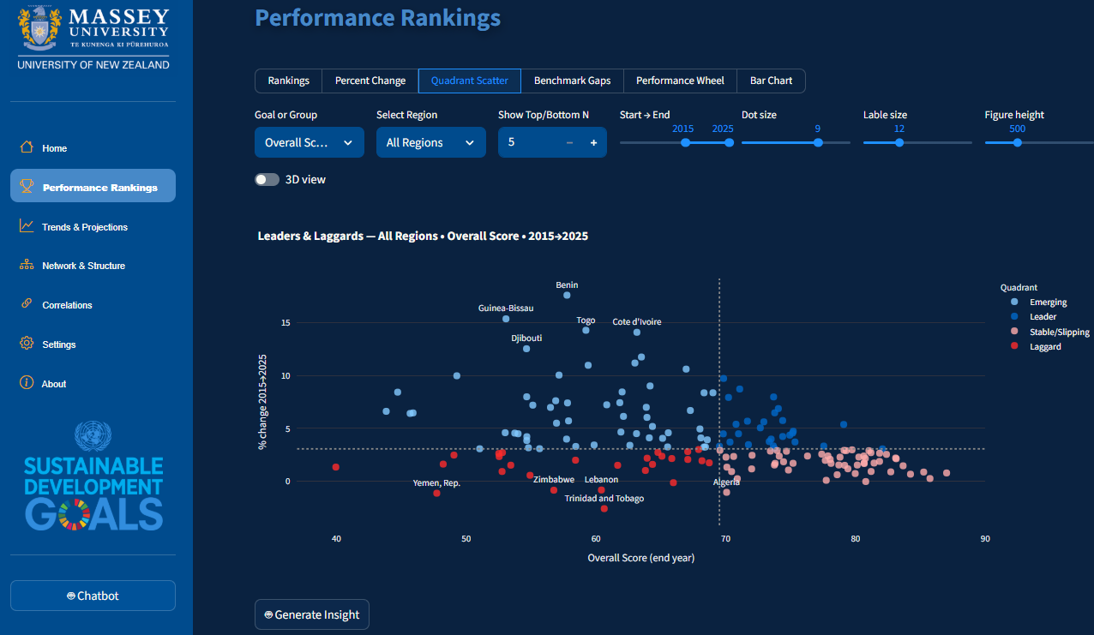
App link: GoalScope SDG Analytics Hub · Streamlit
All analysis scripts and the GoalScope Streamlit app are hosted at the public repository:
jeseacor/sdg_streamlit: https://github.com/jeseacor/sdg_streamlit
Executable notebook (Kaggle): Analyzing Global SDG Indicators – Reproducible build of key figures — runs end-to-end with the same data snapshot. https://www.kaggle.com/code/jeseacor/analyzing-global-sdg-indicators

Software Stack: Python (Python Software Foundation, 2025), NumPy (Harris et al., 2020), pandas (pandas development team, 2025), scikit-learn (Pedregosa et al., 2011), Plotly (Plotly Technologies Inc., 2025), Streamlit (Streamlit, 2025), OpenAI API (OpenAI, 2025).

SDG Predictions App (Ceka, 2025)
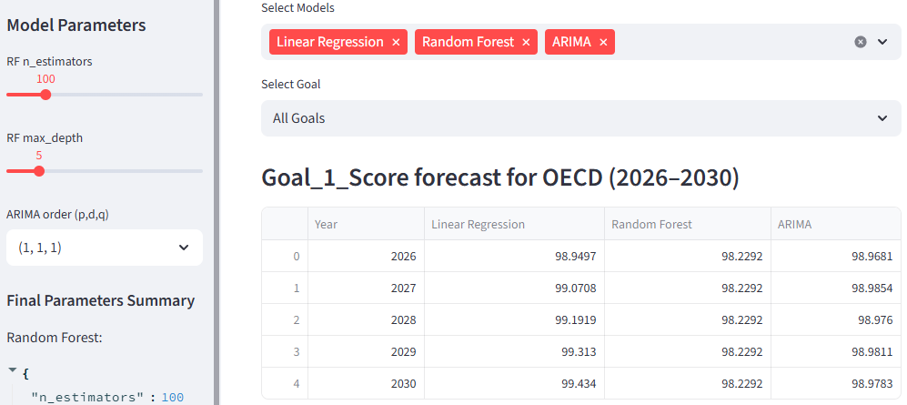
The predictive component of the Predictions App extends the analytics engine described earlier by incorporating machine-learning and time-series forecasting capabilities. This module allows users to forecast SDG performance up to 2030, comparing multiple models for interpretability and precision.
Models Implemented: Linear Regression (LR): Establishes baseline linear trends between Year and SDG scores. Random Forest Regressor (RF): Captures non-linear and interaction effects. Hyperparameters such as n_estimators and max_depth were tuned to balance bias and variance. ARIMA: Models temporal dependencies through parameters (p, d, q), optimised using the Akaike and Bayesian Information Criteria (AIC/BIC) to ensure reliable forecasts.
Evaluation Metrics: Model performance was assessed using Root Mean Squared Error (RMSE), Coefficient of Determination (R²), AIC, and BIC values. RMSE measured average prediction errors, R² evaluated model explanatory power, and AIC/BIC penalised overfitting. Together, these metrics enabled a balanced comparison between linear, ensemble, and temporal forecasts. App link: SDG Predictions App | Github: Sairam123-code/sdg-predictions-app | Kaggle: https://www.kaggle.com/code/sairamceka/sdg-analysis

Challenges encountered and how we resolved them

GoalScope SDG Analytics Hub (Seacor, 2025)

Ranking mismatch with SDR (missing-value fallback).
When we cross-checked our computed rankings against the SDR Rankings site and the 2025 report, we initially observed discrepancies. Investigation showed that where a country has missing values for specific goal scores, SDR falls back to the regional score for that goal in its index calculation. Our first pass treated missing goal values as NA (excluding them from the row mean), which biased some country rankings. We implemented the same regional fallback imputation for missing goal values in our pipeline and recomputed the Overall index and ranks. After this change, our country rankings and top/bottom lists matched the SDR outputs under the same filters and year, giving us a consistent verification baseline.
The following code checks the SDG value (“Goal_*”) if empty then gets the value from the regional score (“Score_reg_*”):

NLP “insight” generation under deployment constraints.
We prototyped on-box models (e.g., Mistral, Flan-T5), but the required model downloads and memory footprint were incompatible with our Streamlit hosting constraints. We switched to an API-hosted LLM (OpenAI) for the “Generate Insight” and chatbot feature, which removed heavy model assets from the deployment and yielded acceptable latency and quality. To manage cost and robustness, we (i) scope prompts to compact table/figure summaries and (ii) keep token budgets low.

Projection reliability with short yearly panels.
With only ~10–25 annual points per country–goal, ETS fitting (level/trend/damping) is fragile and out-of-sample checks are weak. Structural breaks (method updates, COVID) and the bounded 0–100 scale—especially near the edges—further inflate uncertainty. Mitigations: cap horizons at 1–3 years; enforce a minimum history and suppress very short/flat series; default to level-only when AIC/validation doesn’t support a trend; benchmark against naïve baselines and report 80/95% intervals; and flag suspected breaks so results are read as scenarios, not firm predictions.

SDG Predictions App (Ceka, 2025)

Forecast performance
Ensuring temporal and regional consistency proved challenging: our metrics often pulled in different directions. Lowering RMSE and AIC could erode R², obscuring whether the module truly captured SDG trends across diverse countries. Balancing fit and parsimony to limit overfitting while retaining generalisability for 2026–2030 demanded extra validation and careful judgment.

Findings by Research Questions

Global snapshot (2025)

What is the current world average status and trajectory vs 2030 targets?
Answer (see Figures 1 and 2). As per the study’s scale where 100 represents the 2030 target, the closest-to-target group is led by SDG 13 (gap 16.2 points), followed by SDG 12 (gap 22.78) and SDG 1 (gap 24.70). These three are within roughly twenty to twenty-five points of the target and require sustained—but not transformational—late-stage gains.
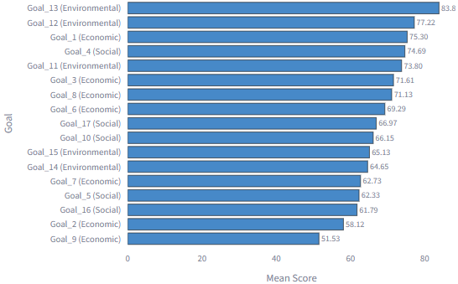
Figure 1: Overall Ranking of SDG Goals for 2025. GoalScope (Seacor, 2025)

A broad needs-acceleration band sits 25–35 points from target: SDG 4 (gap 25.31) and SDG 11 (gap 26.20) head a cluster in the high-60s to low-70s—SDGs 3, 6, 8, 10, 17, 14, 15. These goals are progressing but will not reach the target by 2030 at current pace without policy and investment acceleration. The off-track group faces the largest shortfalls: SDGs 2, 5, 16, and SDG 9. SDG 9 carries the biggest distance to target (gap about 48.5 points) despite being the fastest improver since 2015 (+25.78%). SDG 16 is moving in the wrong direction (−4.74%), widening its already substantial gap. SDG 5 and SDG 2 show positive but insufficient gains relative to their remaining distance. The overall assessment of global progress is grim; according to the United Nations’ 2023 midterm report—as cited in Zerunyan and Duzert—only about 15% of targets are on track, progress on more than 50% is weak or insufficient, and on 30% it has stalled or reversed (as cited in Zerunyan & Duzert, 2025). Implication for 2030: No goal is at or near full attainment. Priorities are: (1) lock in high-level performance on SDGs 13 and 12 while pushing for last-mile gains; (2) accelerate the mid-band (SDGs 4, 11, 3, 6, 8, 10, 17, 14, 15) through targeted policy packages; and (3) mount focused turnarounds for the off-track set—especially SDGs 16, 9, 5, 2—if the global average is to close meaningful portions of the remaining gaps by 2030.
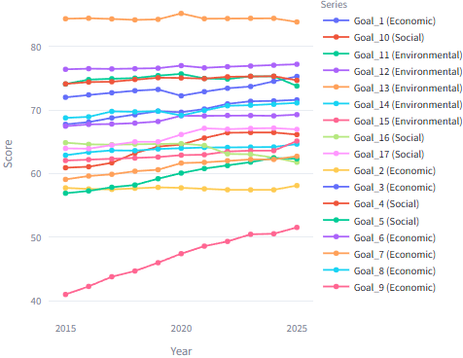
Figure 2: SDG Timeline – 2015 to 2025. GoalScope (Seacor, 2025)

Which regions lead and which lag on the overall score in 2025?
The OECD leads the regional ranking in 2025 (Figure 3) with an overall score of 79.70, followed by Eastern Europe & Central Asia (73.71). An upper-middle tier sits just under 70—Latin America & the Caribbean (68.35) and East & South Asia (68.03). MENA (64.93) and Oceania (63.19) are below the global middle. Africa records the lowest overall score at 56.39. The spread between the leader and laggard is 23.31 points, indicating sizable regional dispersion in progress toward the 2030 targets.
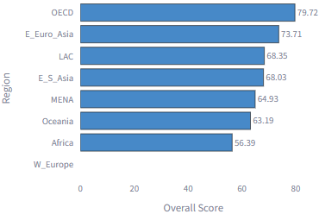
Figure 3: Regional Overall Score. GoalScope (Seacor, 2025)

This pattern is consistent with prior work: OECD members tend to exhibit the highest overall performance (Breuer et al., 2022), and their scores largely reflect already advanced socio-economic baselines (Finnveden, Verhoef, & Newman, 2020).

OECD SDG performance profile, 2025
Figure 3 show us that the OECD records the highest regional overall SDG score in 2025 (79.7), In Figure 4 we see strengths in the socio-economic core (Goals 1, 3, 4, 6, 7, 9, 11) and the main gaps in the environmental block—especially SDG 12 (58.45), plus SDGs 14–15 and 13. The plot shows a classic advanced-economy wheel: the social–economic SDGs (1, 3, 4, 6, 7, 8, 9, 11) are long and even; the environmental pillar is shorter and uneven, with a clear trough at SDG 12 and softer bars on SDG 14–15. A smaller dip at SDG 2 and SDG 17 reflects dependencies on food systems and cross-border coordination. In short: strong services and infrastructure; patchier progress on production–consumption, nature, and enablers. Barbier and Burgess (2021) confirm similar findings: OECD countries—typically classified as high-income in SDG assessments—tend to achieve high overall SDG scores, with strengths concentrated in foundational social and economic domains. High-income countries are commonly on track or maintaining achievement across core economic and social objectives (SDGs 1–9), including reducing extreme poverty and improving access to basic services.
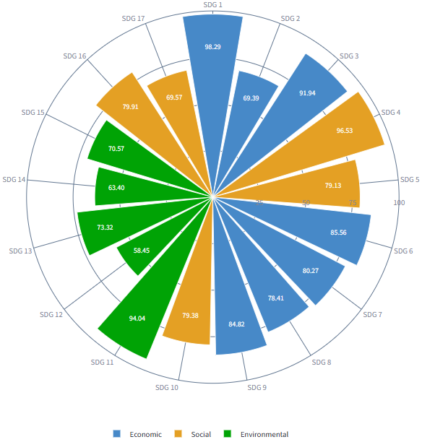
Figure 4: Performance Wheel - OECD. GoalScope (Seacor, 2025)
Implication: With many social–economic SDGs near the ceiling (diminishing returns), the headroom—and policy leverage—lies in the sustainability transition: SDG 12, 14–15, and the enablers SDG 2/17. Priorities: resource-efficiency/circular standards, producer responsibility, green procurement and innovation, nature-positive investment, resilient food systems, and international partnerships / finance. The next step-change comes less from expanding services and more from embedding circular, nature-positive production and deeper cooperation into the existing economic base.

Africa SDG performance profile, 2025
Africa records the lowest regional overall SDG score in 2025 (Figure 3), well below the OECD. Many African countries, classified as low-income economies, have generally performed poorly in attaining all SDGs (Barbier and Burgess, 2021). As shown in Figure 5, the performance wheel is asymmetric: the environmental SDGs form the longest arc—especially SDG 12 (responsible consumption/production) and SDG 13 (climate action)—while several basic-service and inclusion SDGs are short, with clear troughs around SDG 6 (clean water and sanitation) and SDG 10 (reduced inequalities) and softer bars on SDG 1–4. A mid-tier ridge appears at SDG 9 (industry/innovation/infrastructure) and SDG 17 (partnerships), indicating momentum in infrastructure and cooperation even as household-level services lag. Implication: The profile suggests a two-track agenda. First, close foundational gaps—water and sanitation (SDG 6), poverty/health/education (SDG 1–4), and inequality (SDG 10)—because these constrain progress across the system. Second, protect and translate the environmental advantage (high scores on SDG 12–13, and relatively solid SDG 14–15) into growth that remains nature-positive as incomes rise; without policy, catch-up industrialisation can erode today’s strengths. Practically, that points to integrated packages: service delivery + jobs and energy access (SDG 7–8–9) paired with circular-economy standards and nature investment (SDG 12, 14–15), backed by finance and technology partnerships (SDG 17).
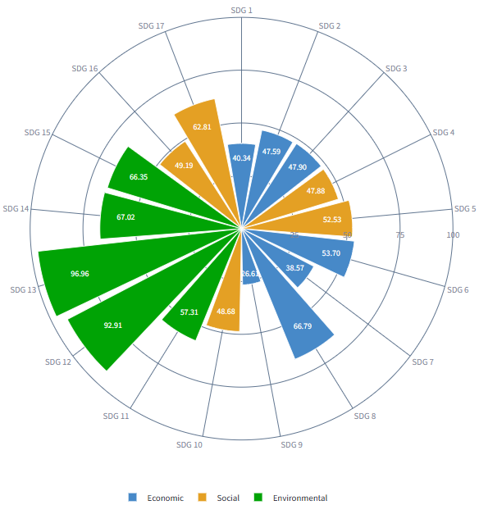
Figure 5: Performance Wheel - Africa. GoalScope (Seacor, 2025)

Change & momentum

Which SDG goals account for the largest positive change between 2015 and 2025, and which goals show stagnation or decline, based on % change in the goal index?
The % change from 2015 to 2025 (Figure 6) shows the largest relative improvement occurs for SDG 9 industry innovation and infrastructure at 25.84%. Meaningful gains follow for SDG 5 gender equality at 9.52% and SDG 10 reduced inequalities at 8.05%. Moderate increases are observed for SDG 7 affordable and clean energy 6.26% SDG 1 no poverty 6.08% SDG 3 good health 5.74% SDG 15 life on land 5.01% and SDG 17 partnerships 4.68%. Smaller but positive movements appear for SDG 8 decent work 3.49% SDG 14 life below water 2.76% SDG 6 clean water and sanitation 2.61% SDG 12 responsible consumption and production 1.04% SDG 2 zero hunger 0.61% and SDG 4 quality education 0.49%. SDG 11 sustainable cities and SDG 13 climate action are essentially unchanged. SDG 16 peace justice and strong institutions decline by minus 4.80%. The pattern indicates a growth and innovation led improvement concentrated in SDG 9, supported by advances in gender equality and inequality reduction. However, institutional quality weakens and climate action together with sustainable cities shows little momentum. Policy priorities should therefore sustain the innovation gains while instituting corrective measures for institutions and accelerating delivery for climate and urban sustainability to convert the flat lines into measurable progress by 2030. These 2015–2025 results are broadly consistent with earlier evidence: Hegre, Petrova, and von Uexkull (2020) found no global improvement for SDG 10, SDG 12, and SDG 16 during 2000–2016. In our data, SDG 10 improves by 8.57%, SDG 12 edges up 1.04%, and SDG 16 declines by 4.74%, indicating a partial break from earlier stagnation on inequalities, only marginal movement on responsible consumption and production, and continued weakness in institutions (see Figures 1 and 6).
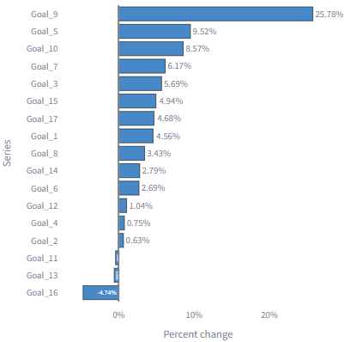
Figure 6: SDG Percent Change – 2015 to 2025. GoalScope (Seacor, 2025)

Which countries improved the most—and which slipped—on the Overall SDG Index between 2015 and 2025, and what patterns by region and starting level emerge?
Figure 7 shows the fastest improvers on the overall SDG score over 2015–2025 are Côte d’Ivoire, Togo, Benin, Guinea-Bissau, and Djibouti. All five rise across the decade, with the West African cases showing the steepest and most sustained climbs, and Djibouti improving more gradually. By contrast, Figure 8 shows the slowest progress group—Trinidad and Tobago, Lebanon, Algeria, Zimbabwe, and Yemen—is largely flat to slightly negative; several series soften after 2019, indicating stalled momentum rather than catch-up. This pattern—faster gains from lower baselines and slower gains from higher baselines—is consistent with the broader literature: the Sustainable Development Report 2025 notes that high-income/OECD economies advanced more slowly on the SDG index, while lower- and lower-middle-income groups posted the largest improvements (Sachs, Lafortune, Kroll, Fuller, & Iablonovski, 2025).
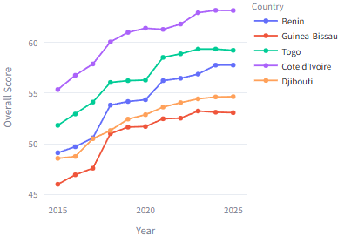
Figure 7: Countries with fastest progress (% change) . GoalScope (Seacor, 2025)

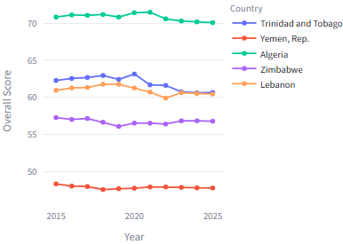
Figure 8: Countries with slowest progress (% change) . GoalScope (Seacor, 2025)

Implication: The country evidence points to mild convergence on the index scale: late starters are closing distance, but many high-baseline countries are plateauing, suggesting that further gains will require structural shifts rather than incremental policy adjustments.

Within the OECD, do any members show downward trends in specific goals?
To answer this question, we first run a triage at the OECD level (2015–2025) to identify the goals with the smallest—or negative—% change on the index scale then perform country drill-downs by goal, ranking OECD members by decade %Δ for each flagged goal to pinpoint which countries drive those declines. Next, we cross-check these goal-level results against each country’s Overall trajectory to confirm that the identified goal slippage is material to overall progress.

Triage at the OECD level (2015→2025)
Before naming specific countries, we first check which goals are moving down on average within the OECD. Figure 9 shows the OECD average from 2015 to 2025, two SDGs fall—SDG 16 (−3.16%) and SDG 2 (−2.19%)—while SDG 6 (+0.12%) and SDG 1 (+0.32%) are essentially flat. Gains are modest and concentrated in the socio-economic core, led by SDG 9 (+8.08%), SDG 5 (+7.16%), and SDG 17 (+4.14%); most other goals rise by less than 3%. This OECD pattern aligns with Barbier and Burgess (2021): high-income systems tend to maintain strength across foundational social and economic goals, while progress on environmentally linked areas is weaker—consistent with the marginal movement in SDG 12 and the decline in SDG 16 in our results.
This OECD-mean view is diagnostic, not definitive: a negative average implies several members are trending down (enough to pull the mean below zero), but it does not mean all are. It narrows the search to problem goals (SDG 16, SDG 2; plus near-flat SDG 6, SDG 1) where country-level declines are most likely. In the next step, we examine country trajectories within these goals to identify which OECD members are driving the downward movement. Next step is we focus on the four weakest OECD goals (Figure 10). From the OECD-mean triage, the bottom four goals by % change are SDG 16, SDG 2, SDG 6, and SDG 1. The small multiples below rank countries by decade %Δ for each goal and plot the bottom five trajectories to show where declines (or near-stalls) are concentrated.
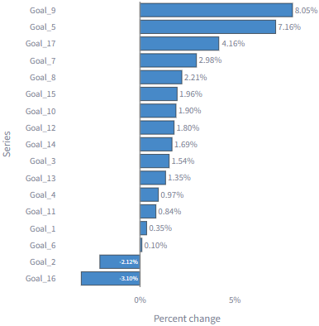
Figure 9: SDG Percent Change – OECD - 2015 to 2025. GoalScope (Seacor, 2025)
- SDG 16 - broad deterioration from high bases. The weakest decadal paths are Mexico, Chile, Canada, Poland, Greece. Mexico shows a persistent slide from the low-50s toward the mid-40s by 2025. Chile and Canada erode from the mid/upper-80s to the low/mid-70s–80s with only partial stabilization late in the period. Poland and Greece drift down a few points. This confirms that the OECD’s negative average on SDG 16 reflects multiple members moving down, not a single outlier.
- SDG 2 - food security slippage in several members. Costa Rica, Israel, Latvia, Estonia, Hungary make up the bottom five. Most display a step-down around 2016–2018 followed by flat or only partial recovery to 2025, leaving the decade change negative. The declines are modest in level but systematic in direction.
- SDG 6 - small but clear declines, led by New Zealand. The bottom five (New Zealand, Poland, Lithuania, Austria, Greece) mostly show gentle drifts downward from already high scores; New Zealand posts the clearest fall, with others edging down or flatlining just below prior peaks. These are tight bands—signals of stagnation/erosion rather than collapse.
- SDG 1 - ceiling effects with one volatile case. In Colombia, Australia, Germany, France, Switzerland, SDG 1 is near the ceiling (98–100) for four countries and flat over the decade. Colombia is the exception: a mid-period drop with partial recovery by 2025, which is why it appears in the bottom-five ranking even though the group as a whole is stable.
The downward pressures within the OECD are goal-specific and heterogeneous:
- Institutional quality (SDG 16) shows the widest and clearest deterioration across several members.
- Zero Hunger (SDG 2) and Clean Water (SDG 6) exhibit modest but persistent slippage in a handful of countries.
- No Poverty (SDG 1) is largely flat at high levels, with one volatile outlier.
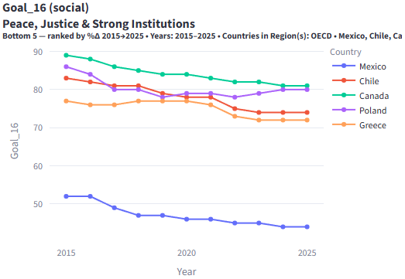 | 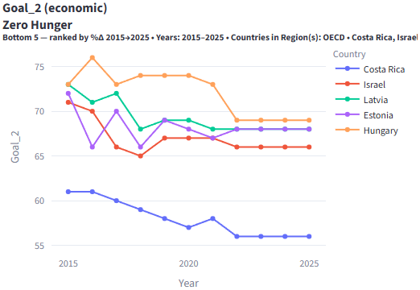
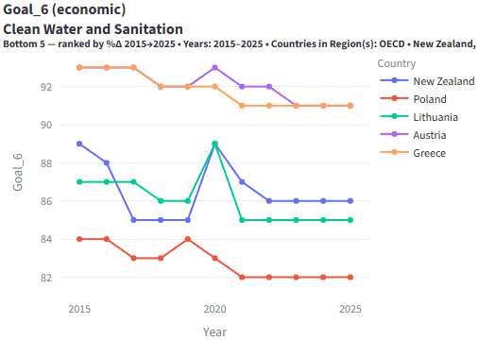 | 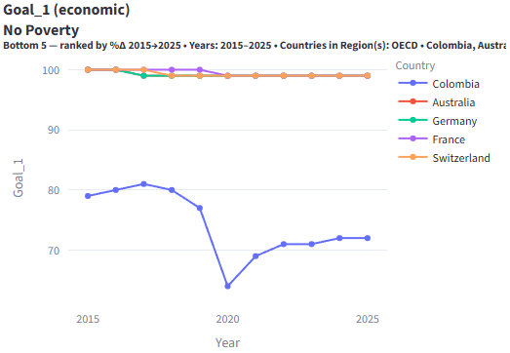
Figure 10: Countries under the lagging SDGs for OECD - 2015 to 2025. GoalScope (Seacor, 2025)

These four goal lenses narrow the subsequent analysis to which countries are actually driving the OECD’s weak decade outcomes, and which sub-components within those goals require targeted policy attention.

Cross-check at Overall level
The OECD Countries with lowest % change are shown in Figure 11. Here we can see that Sweden sits on a stable high plateau, retaining the lead throughout; Austria tracks just below it with similarly low volatility. Iceland holds a steady mid-80s band, showing little drift. The movement is mainly in the lower pair: Ireland dips early and then catches up gradually, while New Zealand bottoms mid-decade and edges upward but remains the laggard by 2025. Overall, the spread between the top (Sweden/Austria) and the bottom (New Zealand) narrows only slightly—a mild convergence without any leadership change. With the leaders already near the ceiling of the index, gains are incremental; the scope for bigger improvements sits with the trailing countries, which will need targeted, goal-specific lift rather than broad, across-the-board changes to close the remaining gap.
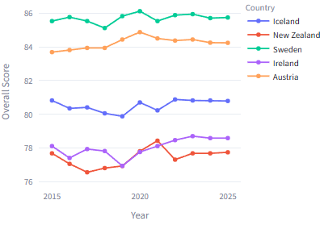
Figure 11: OECD Countries with slowest progress (% change) . GoalScope (Seacor, 2025)

Regional gaps & dispersion

Across Africa, which countries are the SDG “leaders”, “emerging improvers”, “stable/slipping” and “laggards” when we consider both level (end-year score) and momentum (% change over 2015→2025)?
As we saw in Figure 3 that Africa posts the lowest regional Overall Score in 2025 (56.4), we focus the level-by-momentum quadrant on this region. Using Africa-specific medians to split the field, the picture is two-speed: a small leader tier sits above the regional level median and continues to improve; a broad emerging band is climbing quickly from below the median. Notably, Benin (+17.6%), Guinea-Bissau (+15.5%), and Togo (+14.5%) are among the fastest improvers over 2015→2025, signaling reform traction despite lower starting points. By contrast, several countries remain stable/slipping (highish levels but weak recent gains) and a tail of laggards combines low levels with low momentum, indicating priority need for targeted support. In short, Africa’s regional average is lowest, but the quadrant shows clear pockets of momentum that can be scaled, while highlighting where progress is stalling. This pattern aligns with the literature: the Sustainable Development Report 2025 identifies Benin and Togo as the top global improvers despite low overall ranks, confirming the momentum seen in the data (Sachs et al., 2025).
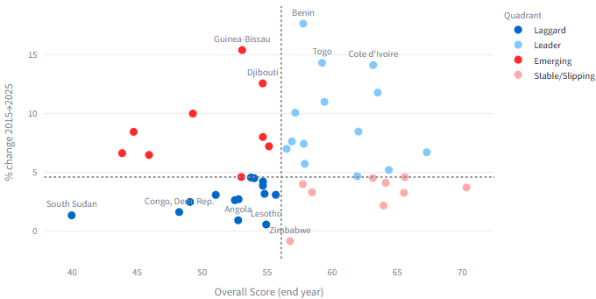
Figure 12: Quadrant Scatter – Africa – 2015 to 2025. GoalScope (Seacor, 2025)

Inter-goal links & trade-offs

In the 2025 global network of SDG goal scores, which goals are central “synergy hubs,” which are peripheral, and where are the main trade-offs?
The correlation network Figure 13 (nodes = SDG goals; red = positive ties; blue = negative) and Figure 14 shows a dense socio-economic core and a thin environmental periphery (Figure 13). Central synergy hubs—goals whose progress propagates system-wide—are SDG 3, SDG 9, SDG 4, SDG 6, and SDG 1, consistent with the view that effective governance can act as an SDG accelerator (Organisation for Economic Co-operation and Development [OECD], 2019). These hubs also form the strongest positive pairs in our data: SDG 3–SDG 9 (r = 0.86), SDG 3–SDG 7 (r = 0.84), SDG 1–SDG 3 (r = 0.82), and SDG 3–SDG 4 (r = 0.82). At the trade-off pole, SDG 12 is most negative—SDG 12–SDG 9 (r = −0.85), SDG 12–SDG 3 (r = −0.80), SDG 12–SDG 16 (r = −0.80)—with SDG 13 showing additional moderate negatives against several core goals. Implication: prioritize circular-economy and clean-tech packages to decouple growth from resource use and convert these trade-offs into complements. Peripheral environmental goals: SDG 14 Life Below Water and SDG 15 Life on Land appear as small, sparsely connected nodes with mostly weak links—consistent with their low average association with the core block. SDG 13 Climate shows modest positive links to some social goals but remains off the main axis. The 2025 SDG system is core–periphery: a tightly integrated health–education–Infrastructure–water–poverty cluster drives overall performance, while environmental goals—especially SDG 12 and SDG 13—do not co-move with that core and often move in the opposite direction. Policy leverage thus lies in (i) protecting and compounding the socio-economic synergies, and (ii) targeted instruments (circular-economy standards, clean-tech diffusion, resource-efficiency regulation) to reduce the observed SDG 12 and SDG 13-center trade-offs and bring environmental outcomes into the core of progress.
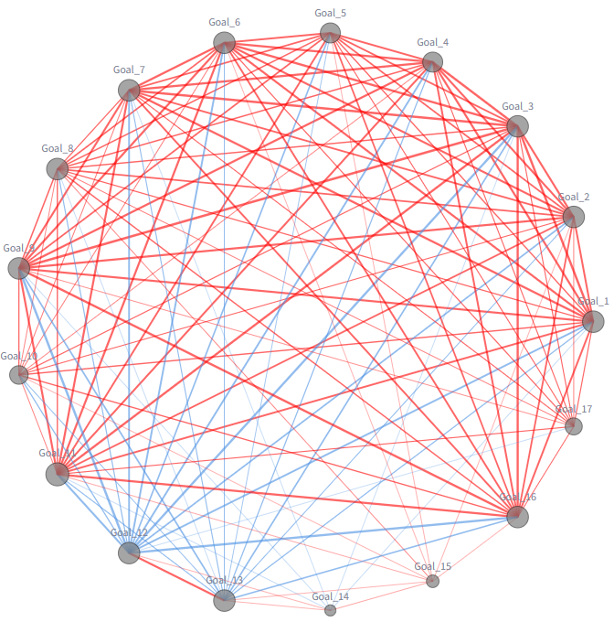
Figure 13: Network Graph of Goal Correlations - 2025. GoalScope (Seacor, 2025)

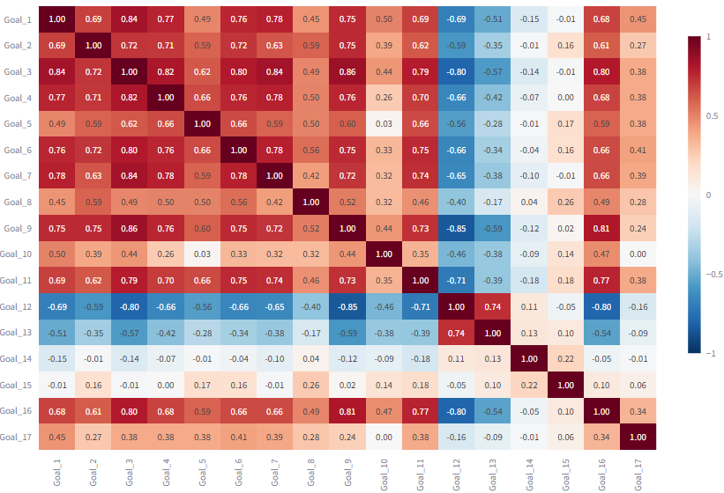
Figure 14: SDG Correlation Matrix – All Regions - 2025. GoalScope (Seacor, 2025)

What latent structure organizes cross-country SDG performance in 2025, and which goals align with—or run counter to—the dominant development axis?
A PCA on country-level goal scores reveals two principal dimensions (Figure 15). PC1 (53.6% of variance) is a broad “socio-economic capacity” axis. Goals that load strongly and positively on PC1 cluster to the right of the circle: SDGs 9, 8, 7, 3, 4, 5, 6 and SDG 17. Countries scoring well on one of these tend to score well on the others—these arrows are long and tightly aligned. In contrast, the environmental production/consumption and biosphere goals—SDG 12, 13, 14, 15—load to the left, i.e., negatively on PC1, marking a structural contrast with the socio-economic cluster.
PC2 (9.0%) separates SDG 10 (Reduced Inequalities)—which points downward with a large projection—from the rest, indicating a distinct inequality axis that is only weakly aligned with the main development gradient. Geometrically, the small angles within the economic–social set indicate strong positive intercorrelations, while the near-opposite directions between environmental goals and the socio-economic set reflect weak or negative links. This pattern is consistent with Figure 16 cross-group correlation summary (economic↔social +0.53; economic↔environmental −0.08; environmental↔social −0.05): environmental performance does not automatically rise with socio-economic gains. Policy implication: progress on SDG 12–15 likely requires targeted instruments (e.g., circular economy and clean-tech diffusion) to align environmental outcomes with the development core rather than relying on spillovers from health/education/infrastructure improvements.
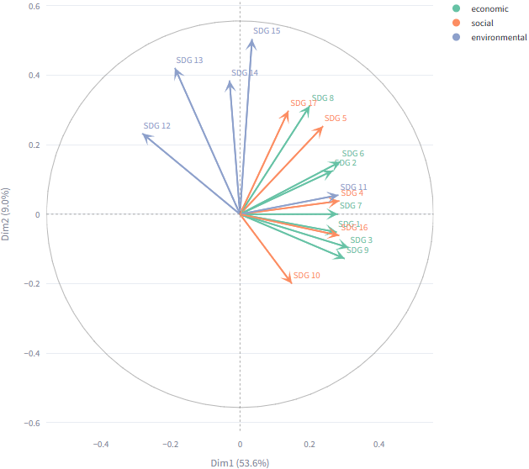
Figure 15: PCA Correlation Circle. GoalScope (Seacor, 2025)

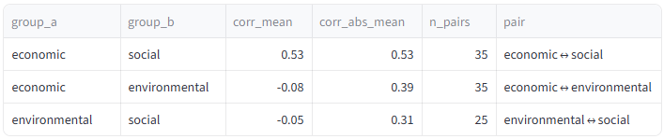
Figure 16: Cross-Group Correlation Summary

Which goals are most strongly linked with the Overall score in 2025?
From the 2025 country-level analysis, the goals that track the Overall SDG score most closely are those at the heart of the economic–social block. In particular, SDG 3 is the single best proxy for Overall, followed by SDG 9, 4, 1, and 6. Figure 17 shows that these goals co-move strongly with one another (the matrix shows uniformly warm tones within economic↔social) and with the overall index, so countries that score high on them almost always have high Overall scores as well.
By contrast, the environmental goals (SDG 11 – SDG 15) show weak or mixed associations with Overall: several are near zero and SDG 12 tends to tilt negative against high-performing economic/social systems. In short, Overall, in 2025 is driven chiefly by the health/education/infrastructure/poverty-reduction cluster, while environmental performance does not systematically rise with it across countries.
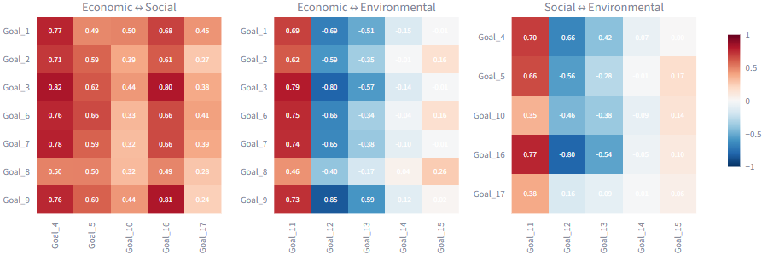
Figure 17: Cross-Group Correlation Matrix. GoalScope (Seacor, 2025)

Which goal pairs move together the most and which show trade-offs in 2025?
Figure 18 shows us that using country-level SDG goal scores for 2025 (Pearson r across countries), we identified the strongest co-movements (positive correlations). Countries that score highly on health tend also to score highly on infrastructure, energy access, poverty reduction, education, institutions, and water—a broad package of public-goods capacity moving together.
The clearest trade-offs (negative correlations) are:
- SDG 9 “Industry, Innovation & Infrastructure” ↔ SDG 12 “Responsible Consumption & Production”: r = −0.85
- SDG 3 “Good Health & Well-being” ↔ SDG 12: r = −0.80
- SDG 12 ↔ SDG 16 “Peace, Justice & Strong Institutions”: r = −0.80
Interpretation: Performance on responsible consumption & production (SDG 12) tends to move opposite to several economic/social goals (notably innovation/infrastructure and health, and also institutions)—consistent with production/consumption pressures that are not yet fully decoupled from resource use and social externalities in many countries.
Big picture: Economic ↔ social pairs are generally complementary (cross-group mean +0.53), whereas economic ↔ environmental and environmental ↔ social show near-zero to negative averages—so environmental progress often does not “ride along” with social/economic gains and needs targeted policy to align incentives (e.g., circular economy and clean-tech diffusion to turn the SDG 9 – SDG 12 tension into a synergy).
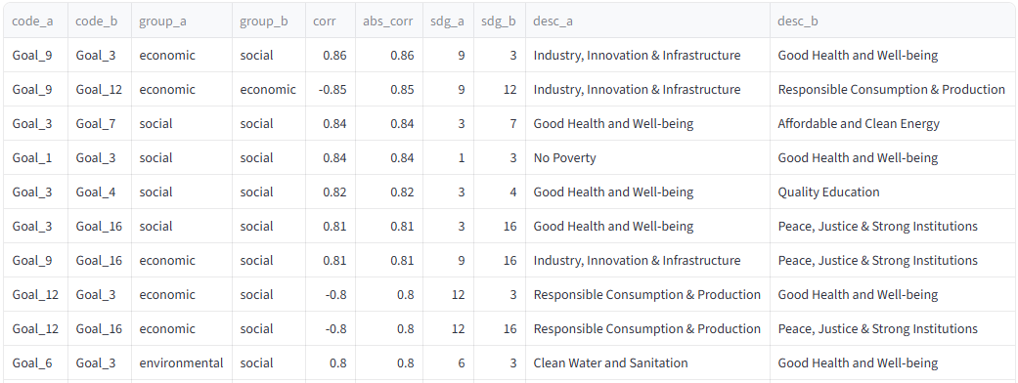
Figure 18: Group-Pair Correlations. GoalScope (Seacor, 2025)

Where does New Zealand stand on the SDGs in 2025, which goals are lagging, and what cross-goal linkages (synergies/trade-offs) explain those gaps—so where should policy focus to accelerate progress to 2030?
This section takes stock of New Zealand’s SDG position in 2025 and the momentum since 2015, then turns that picture into a policy shortlist. First, we show overall score and rank with goal trend lines to flag any flat or slipping goals. Next, we size the gap to the OECD median and the OECD top quartile for each goal to see where the shortfall really sits. We then map cross goal links with correlation to separate reinforcing bundles from tradeoffs, especially around responsible production and climate versus growth and industry. Finally, we drill down to the indicators that explain each lagging goal and point to practical levers. The outcome is a clear set of priority goals and actions to accelerate progress to 2030.

Overall Standing, Rank, and Goal-Level Imbalances (2025)
Performance across the New Zealand SDGs is uneven (Figure 19). Standout strengths are SDG 11 (98.08), SDG 3 (92.77), SDG 4 (90.18), and SDG 9 (90.09). The economic-leaning goals (blue) are generally robust—SDG 3 (92.77), SDG 6 (86.35), SDG 7 (84.54), and SDG 8 (82.28)—while environmental outcomes are polarized: an exceptional SDG 11 (98.08)
contrasts with very weak SDG 12 (48.30), SDG 14 (51.44), and SDG 15 (51.66), signaling deficits in responsible consumption and biodiversity on land and sea. Social results are mixed; SDG 16 is high (89.38) but SDG 10 (77.50) and SDG 17 (78.99) sit midtable, suggesting scope to strengthen inclusion and partnerships. The lowest scores cluster in the environmental pillar around 48–52, pulling down that average. Overall, scores span roughly 48–98 (50-point spread), indicating substantial variance across goals rather than uniform performance. With an overall score of 79.0 and a rank of 28/193, New Zealand performs well internationally but should prioritize SDG 12, 14, and 15 to reduce internal imbalances.
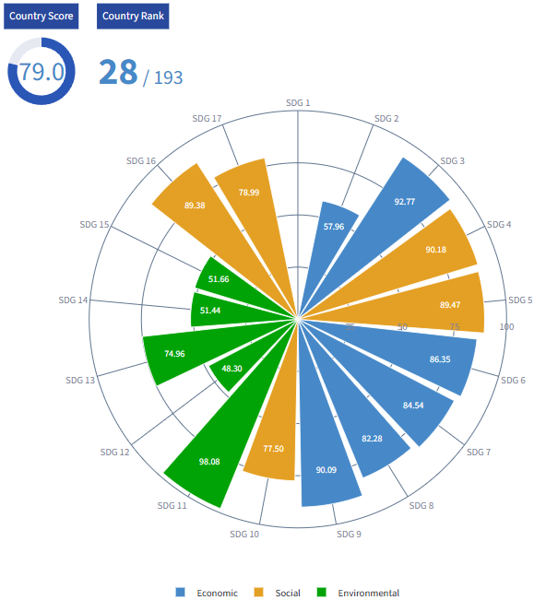
Figure 19: 2025 Performance Profile – New Zealand. GoalScope (Seacor, 2025)

Status & momentum: NZ’s overall score/rank in 2025 and % change over 2015→2025; goal-by-goal trend lines to flag any downward or flat goals.
Figure 20 shows a two-speed profile over 2015–2025. A broad band of social–economic goals stays high and steady—basic services and infrastructure remain strong with little room left for large %age gains. By contrast, the environmental cluster is volatile: the production/consumption transition surges around 2019–2020 before easing back, and the nature goals track below the social–economic plateau, signalling unfinished work on circularity and biodiversity. A small group of inclusion-type goals sits well lower and moves only gradually—an early-decade dip is followed by a slow recovery—pointing to persistent gaps in distributional outcomes. Taken together, the pattern suggests that New Zealand’s next lift will come less from expanding already-mature services and more from accelerating the sustainability transition (responsible production, oceans, land) while closing inclusion gaps; otherwise, the trajectory will remain stable but flat. Figure 21 shows that momentum is uneven: gains are concentrated in SDG 12 and SDG 5, with smaller positives around SDG 15, and SDG 17, while several areas are flat and a few retreat. The clearest weakness is the environmental/biosphere edge, led by a sharp decline in SDG 14 (life below water) and a drop in SDG 4 (quality education), with additional slippage in SDG 2, SDG 6, SDG 10, SDG 16, and SDG 3. Read alongside Figure 20’s level profiles, the message is that New Zealand’s strong social–economic base is holding but momentum has cooled where environmental protection, inclusion, and governance are concerned. Near-term policy lift therefore sits in marine and freshwater quality, circular production, equitable outcomes, and institutional performance, while sustaining the already high social–economic SDGs that show little headroom for large %age gains. There are noted limitations in New Zealand-based empirical studies focusing specifically on achieving SDG 12 (Responsible Consumption and Production) within the context of Agenda 2030 (Tauringana and Moses, 2022). Policy to 2030 should center on water and ocean recovery, a faster circular economy to lift SDG 12, a bigger clean energy and climate push that reinforces nature goals, and sustainable farming that raises food and land outcomes.
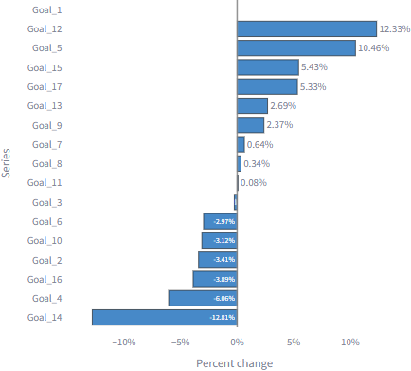
Figure 21: SDG Percent Change – New Zealand – 2015 to 2025. GoalScope (Seacor, 2025)

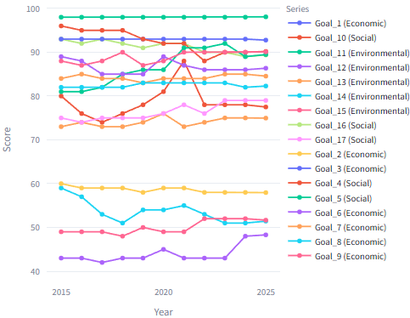
Figure 20: SDG Timeline – New Zealand. GoalScope (Seacor, 2025)

Gap analysis: Distance (points and %) from the OECD top-quartile for each goal, highlighting the few goals that dominate the shortfall.
The benchmark plot (Figure 22) shows New Zealand’s largest distances to the OECD top-quartile cluster are concentrated in SDG 15, SDG 14, and SDG 12, indicating a clear frontier gap on the environment/circularity axis. Mid-tier gaps persist in SDG 10 and SDG 2, with smaller but non-trivial shortfalls in SDG 4, SDG 9, and SDG 6. By contrast, New Zealand is at parity or slightly ahead on SDG 5, SDG 8, SDG 16, and SDG 11, signalling relative strength in social/economic capacity and governance.
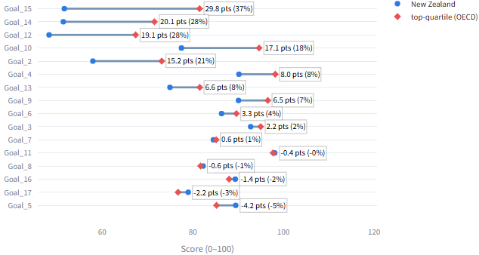
Figure 22: New Zealand gap to OECD top-quartile. GoalScope (Seacor, 2025)

Implication. The shortest route toward the frontier is to close the three environmental gaps (SDG 12, 14, 15), supported by targeted action on distributional and food-system dimensions (SDG 10, 2). These priorities should be pursued while sustaining current advantages on SDG 5, 8, 16, 11, which are already at or above the benchmark.

Structure & drivers: Which goal bundles in New Zealand move together from 2015 to 2025 and where do the main tradeoffs sit, so what two or three policy packages would deliver the biggest co benefits by 2030?
The correlation matrix (Figure 23) shows two clear bundles. First, a socio-economic core—SDG 1, 3, 4, 6, 7, 8, 9, 11, 16—that tends to rise and fall in concert, consistent with shared drivers such as income, service delivery, infrastructure, and institutions. Second, a coherent environmental bundle—SDG 12–15—that is tightly knit internally but only loosely aligned with the socio-economic core. Tensions appear at the interface between production-oriented SDGs (7, 8, 9) and the environmental set (12–15): periods of industrial and consumption growth do not automatically translate into circularity or nature outcomes and can pressure oceans and biodiversity. A few local negatives also involve SDG 2 and SDG 5, which likely reflect indicator composition and short-sample volatility rather than hard structural antagonism; they warrant robustness checks before policy interpretation.
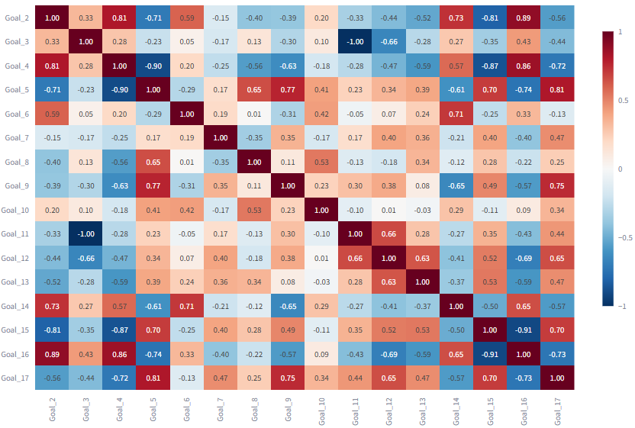
Figure 23: SDG Correlation matrix across years 2015 to 2025 – New Zealand. GoalScope (Seacor, 2025)

Policy packages with the biggest co-benefits by 2030.
- Clean industry & circular production (SDG 12, 13 ↔ 7, 9).
  - Instruments: resource-efficiency and eco-design standards, extended producer responsibility, industrial electrification and heat pumps, green public procurement, innovation support for low-waste manufacturing.
  - Co-benefits: emissions and waste reduction (SDG 13/12), productivity and export readiness (SDG 9), air-quality/health gains (SDG 3), green jobs (SDG 8).
- Blue–green catchments & coasts (SDG 6, 14, 15 ↔ 2).
  - Instruments: river-catchment nutrient limits, riparian restoration, marine protected areas, invasive-species control, regenerative agriculture and precision fertiliser use.
  - Co-benefits: improved freshwater/marine quality (SDG 6/14), biodiversity recovery (SDG 15), resilient food systems (SDG 2), regional employment and tourism (SDG 8).
- Inclusive skills & liveability backbone (SDG 1, 3, 4, 10, 11, 16).
  - Instruments: targeted upskilling and digital inclusion, affordable/efficient housing and transit, place-based inequality reduction, open-data accountability for service outcomes.
  - Co-benefits: human-capital lift (SDG 4), participation and productivity (SDG 8), safer cities (SDG 11), stronger institutional performance (SDG 16), which in turn enables the two environmental packages to scale.
Together, these packages align with the matrix structure: reinforce the socio-economic core while hardwiring circularity and nature protection into production and land/sea management. This combination minimizes the observed trade-offs and maximizes co-benefits on the path to 2030.

New Zealand overall score projection to 2030
Figure 24 shows New Zealand’s overall SDG score rises steadily from 2000 to 2025, with small cyclical dips and a clear upswing after 2017. The model projects a brief mean-reversion in 2026 followed by a gradual upward glide through 2030. Both the 80% and 95% prediction intervals widen over the horizon but slope upward, indicating that modest improvement is more likely than decline. On the baseline path, New Zealand remains in the upper-70s by 2030, leaving a substantial gap to the 2030 target of 100.
Implications for policy:
- Expect incremental gains, not another step-change, without new interventions.
- To lift the trajectory, pair productivity/innovation measures with consumption- and climate-oriented policies that reduce trade-offs (e.g., circular-economy and clean-tech adoption), protecting advances in the economic–social core while addressing pressure points linked to SDGs 12 and 13.
- The widening intervals signal uncertainty: outcomes consistent with a mild pullback or a stronger rebound are both plausible; monitoring and mid-course adjustment are warranted.
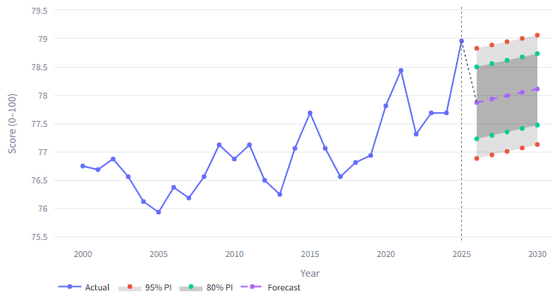
Figure 24: SDG Overall Projection – New Zealand. GoalScope (Seacor, 2025)
s
Method note: Figure 24 shows a univariate forecast of New Zealand’s overall score with 80% and 95% prediction intervals.

Forecasting New Zealand vs OECD on SDG 8 (Unemployment 2026 – 2030)
Figures 25 and Figure 26 illustrate unemployment projections for New Zealand and the OECD average under SDG 8 (Decent Work and Economic Growth). The results reveal a consistent gap favouring New Zealand’s labour-market performance. Between 2026 and 2030, Random Forest and ARIMA (1, 1, 1) models predict unemployment-adjusted scores of ≈ 83–85 for New Zealand (R² = 0.967, RMSE = 0.70) versus ≈ 80 for the OECD mean (R² = 0.09).
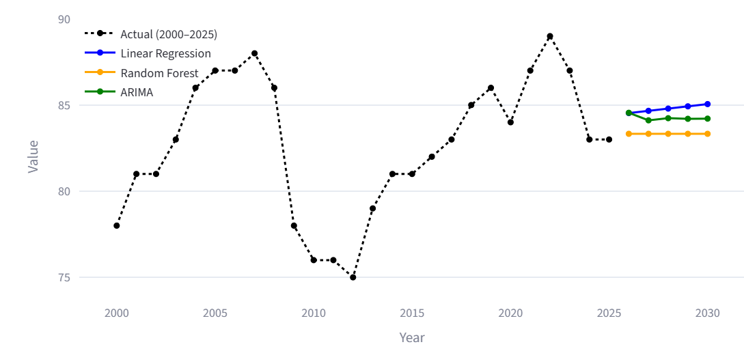
Figure 25: Score_sdg8_unemp forecast for New Zealand (2026–2030). SDG Predictions App (Ceka, 2025)

The divergence highlights New Zealand’s resilient employment framework—anchored in targeted job creation, digital-sector expansion, and adaptive labour policies.In contrast, OECD-wide forecasts indicate slower post-pandemic normalisation and structural rigidity in certain member economies. Random Forest captures New Zealand’s low volatility, while ARIMA signals gradual regional convergence, suggesting balanced recovery across advanced economies by 2030. Overall, the forecasts affirm that New Zealand will sustain lower unemployment and stronger labour-market stability than the OECD average through 2030, supported by policy agility and digital transformation. These results align with global labour market studies highlighting that smaller, flexible economies achieve faster employment recovery and inclusive growth in the post-COVID era.
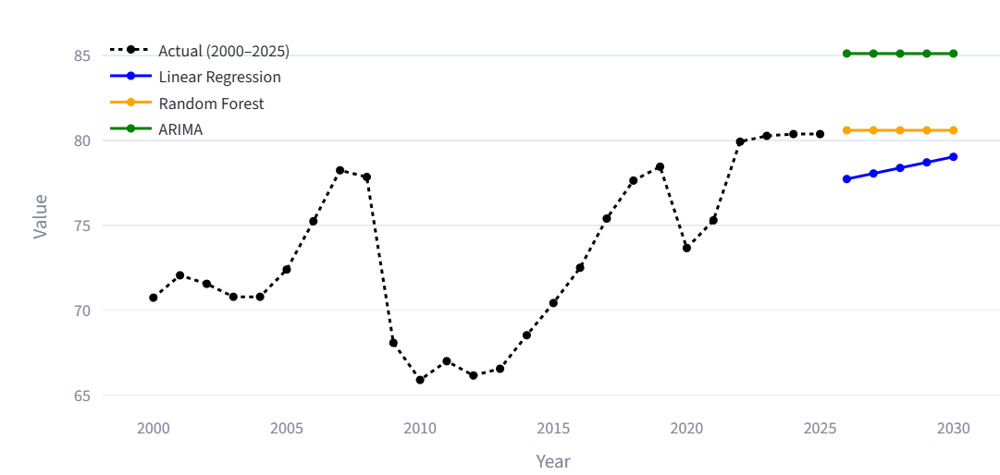
Figure 26: Score_sdg8_unemp forecast for OECD (2026–2030). SDG Predictions App (Ceka, 2025)

Forecasting New Zealand’s Goal 3 and Goal 13 (2026–2030)
Figure 27 and Figure 28 shows New Zealand’s forecasts reveal a clear contrast between social and environmental progress. Health and Well-Being (SDG 3) maintains a steady upward path, rising from ≈ 94.8 in 2025 to 95.9 by 2030, reflecting sustained investment in public healthcare, preventive programs, and equitable access. In contrast, Climate Action (SDG 13) remains almost flat around 75 points, showing limited emission-reduction momentum despite active policy dialogue.
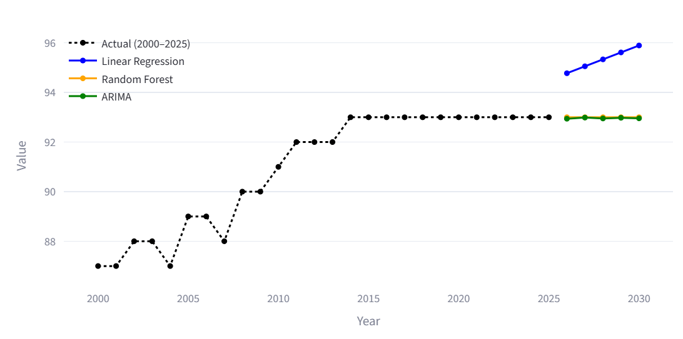Figure 27: SDG 3 forecast for New Zealand (2026–2030). SDG Predictions App (Ceka, 2025)

Random Forest and ARIMA (1, 1, 1) models confirm this divergence (R² = 0.991 for Goal 3; R² = 0.912 for Goal 13). The results highlight that while New Zealand sustains social resilience, its environmental transformation remains slow, largely constrained by agricultural emissions and renewable-energy delays. Aligning the two trajectories will require stronger coordination between climate policy and health-centred adaptation strategies.
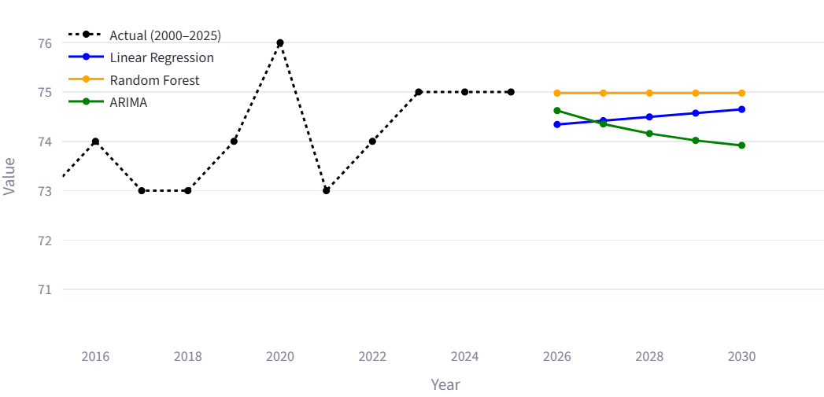
Figure 28: SDG 13 forecast for New Zealand (2026–2030). SDG Predictions App (Ceka, 2025)

Synthesis
This section integrates evidence from the snapshot (levels in 2025), change and momentum (2015–2025), regional gaps, inter-goal structure, and short-term projections to answer the overarching question: where is performance high or low, how is it moving, and what combinations of goals move together or trade off? The synthesis also links these results back to the project objectives—turning open SDG data into reproducible, decision-ready evidence via our analytics apps.
Levels and dispersion: In 2025 there is a clear regional hierarchy; advanced economies cluster at the top, while Africa remains lowest. Yet within-region spread is wide, so regional averages can mask large country differences. This reinforces a core reading principle for all figures: interpret ranks alongside dispersion, not in isolation. Change and momentum: Most countries improve over 2015–2025, with the steepest gains concentrated before 2021; after that, many series flatten. Lower and mid performers tend to converge modestly toward the middle, whereas high performers exhibit diminishing returns near the upper bounds of the 0–100 index. These patterns imply that future step-changes will require policy packages, not more of the same. Structure of the goals: Correlation, clustering, and network views reveal a consistent structure. A socio-economic core—SDGs 1, 3, 4, 6, 7, and 9—moves together and explains much of the Overall score. SDG 12 (responsible consumption/production) and often SDG 13 (climate action) sit closer to the periphery and can pull against the core, producing recurring trade-offs when growth and infrastructure rise without circular-economy or nature safeguards. These relationships are associations, not causation, but they are strong enough to guide bundled interventions.

Actionable policy bundles
Combining the findings suggests three high-leverage packages that convert trade-offs to co-benefits:
- Basic services & human capital (SDGs 1, 3, 4, 6) to lift the core.
- Productive infrastructure & clean energy (SDGs 7, 9) with efficiency standards.
- Nature & circular economy (SDGs 12, 14, 15) to protect gains and meet environmental commitments. Countries can stage these bundles according to starting level and observed gaps.

Country lens (New Zealand)
The national profile is strong overall but imbalanced, with persistent shortfalls in the environmental/circular-economy goals (notably SDG 12 and biosphere goals). The synthesis above therefore points to a targeted package that protects the high socio-economic core while accelerating progress on production/consumption and nature.

Overall message
The evidence is coherent across views: who leads and lags is consistent with how fast they are moving, and the inter-goal structure explains why some improvements stall without complementary action. The analytics system—data pipeline plus apps—makes these conclusions reproducible: every figure in the report can be regenerated from the same code and data, enabling transparent debate about priorities and trade-offs.

Discussion

Overview of patterns
Across countries a strong socio-economic core moves together. Health SDG 3, Education SDG 4, Water and Sanitation SDG 6, Energy SDG 7, Poverty SDG 1, and Infrastructure SDG 9 tend to rise and fall in step. Environmental goals sit more at the edge of the system. SDG 12 Responsible Consumption and Production and often SDG 13 Climate Action do not always move with the core. This core and periphery view appears in the correlation results, in the network view, and in the ranking pages of the app.

Policy implications
- Protect and compound the core. Improving health, education, basic services, and infrastructure lift several goals at once.
- Manage trade-offs with design. The tension between production and environment is not a law of nature. Efficiency standards, circular practices, and clean technology can turn a cost into a co benefit.
- Tailor actions by place. Regions show widespread inside the same group. Country level diagnosis should come before any shared plan.

Reading change correctly
We reported level views and change views. Level views use the goal index from 0 to 100 and are easy to compare. Change views use direction corrected raw trends, which match common practice in the papers we reviewed. Looking at both reduces the risk of over claiming from any single scale.

Strengths and limitations
Strengths include a transparent pipeline, repeatable data steps, multiple regional and country lenses, and an interactive app that keeps plots and numbers tied to the same source. Networks and simple correlation views make structure easy to see. Limitations include possible changes in source methods over time, which can affect year to year comparability. Correlation does not mean cause. Environmental goals often align less with the core, so progress there depends more on policy instruments than on spillovers.

Implications
The results indicate that policy should prioritize reinforcing the socio-economic core (SDGs 1, 3, 4, 6, 7, 9) while explicitly managing trade-offs with environmental objectives, especially SDG 12 and SDG 13, through efficiency standards, circular practices, and clean technology adoption. Interventions should be tailored to country context rather than regional averages, with sequencing that protects core services first and layers environmental instruments where they deliver co-benefits. Short-horizon forecasts should be presented as projections with uncertainty, benchmarked against naive baselines, and revisited as source methods or data are revised.

Conclusion
This project delivers a coherent, working SDG analytics system - GoalScope: a reproducible data pipeline, a Streamlit application with analysis views aligned to policy-relevant questions, and a set of figures/tables that present global rankings, temporal momentum, and cross-goal structure in a consistent way. In terms of the assessment criteria, the work (i) states clear questions, (ii) applies appropriate methodology to answer them, and (iii) provides interpretable findings with transparent limitations (short-horizon ETS projections).
The results show a clear socio-economic core. SDG 1, SDG 3, SDG 4, SDG 6, SDG 7, and SDG 9 move together and explain a large share of performance. Environmental objectives sit more at the edge. SDG 12 and often SDG 13 do not always move in step with the core. This core and periphery structure appears across correlation views, network diagrams, and regional summaries. Policy reading is direct, protect and compound the socio-economic core while managing the tensions with SDG 12 and SDG 13 through efficiency standards, circular practice, and clean technology. Actions should be tailored to country context rather than regional averages, with sequencing that secures core services and then adds instruments that deliver co benefits. Limitations remain, source methods may change over time, which can shift comparability. Correlations reveal structure, not cause. The system’s strongest contributions are: (1) Reproducibility—all visuals come from one codebase and one data version; (2) Traceability—every plot maps to a specific view and dataset; (3) Actionability—rankings highlight leaders/laggards, trend views quantify near-term trajectory with uncertainty, and correlation/network views surface potential synergies (where investments align) and trade-offs (where vigilance is required). Collectively, this meets the report expectation to offer “clear explanation of findings and thoughtful analysis,” with explicit limits and next steps.

Future Work

GoalScope SDG Analytics Hub (Seacor, 2025)
- Expanding data sources: Broaden sources beyond current aggregates by pulling open public data and, where feasible, national datasets directly from country statistical offices and SDG custodians. This will expand coverage, improve timeliness, and—crucially—grow my data acquisition and wrangling skills (API harvesting, schema harmonisation, codebook alignment, and automated QA checks). I will add provenance tracking, a data dictionary, and versioned snapshots to keep the pipeline auditable.
- Custom NLP model for insights: Replace the API-only service with a small in-house model fine-tuned on our chart/table corpus, grounded via RAG from the current view. Build steps: curate labels; fine-tune a 0.5–3B base (or distil); add evals (factuality, numeric/unit tests); enforce guardrails (stay within bands, no policy unless asked); and fall back to API LLMs on low confidence. Result: lower latency/cost and on-prem/air-gapped deployment.
- Full-stack React rewrite & cloud deployment: Evolve GoalScope into a full-stack React (Next.js) application with a typed API layer (FastAPI/Node) and a modular plotting service. Package the analytics module as a backend service and expose endpoints for rankings, timelines, correlations/PCA, and forecasts. Hosting services to be considered are Google Cloud or Snowflake.
- User documentation: Ship a concise user manual and a set of saved “view presets” aligned to the research questions, to help non-technical users replicate the report figures.

SDG Predictions App (Ceka, 2025)
- Model Expansion: Future work will extend the forecasting module with deep-learning and ensemble models such as LSTM and Prophet to capture complex temporal and non-linear SDG patterns. These will complement current Linear Regression, Random Forest, and ARIMA models, improving forecast robustness and adaptability.
- Data Integration: Integrating live UN and World Bank API feeds will automate data refreshes, ensuring real-time updates for SDG indicators. This will enhance data reliability, reduce manual intervention, and support continuous forecasting for new countries and regions.
- Analytical Enhancements: Adding uncertainty bands, confidence intervals, and region-based clustering will improve interpretability and policy relevance. Enhanced dashboards will allow side-by-side forecast comparisons and trend exploration across multiple regions.
- Insight Generation: An AI-driven narrative generator will summarise key forecasts and trends automatically, using SDG-specific language models to produce accessible insights for policymakers and researchers.

Personal learning

Jesus Eric Seacor (24007226) — Over this project I deepened my technical and professional toolkit. On the technical side, I strengthened my data engineering practice—building repeatable ingestion and cleaning pipelines, standardising schemas, validating inputs, and packaging notebook code into reusable modules. I iterated on application UI design (layout consistency, clear controls, informative tooltips, and responsive plots) and tightened my GitHub workflow with branching, pull requests, semantic commits, and tagged releases. I also learned key SDG specifics: how 0–100 goal scores are constructed from indicators, where regional gaps persist, and how synergies and trade-offs emerge, plus the pitfalls of short annual panels and missing data that require cautious imputation and conservative claims. Equally important, I clarified the limits of my models: the projection used here is an extrapolation of recent trends—not a structural forecast—and I now communicate that caveat explicitly in the text and figures. On the professional side, I ran the project like a small product: managing team time, assigning work, keeping minutes of each meeting, and prioritising tasks against deadlines. This combination—sound data plumbing, usable interfaces, disciplined version control, honest modelling caveats, and practical project management—has measurably lifted my capability to execute end-to-end data projects.

Sai Ram Ceka (24011574) — Over this project I strengthened my ability to build and evaluate predictive models for SDG forecasting. I learned to design reproducible workflows using Linear Regression, Random Forest, and ARIMA, applying metrics like RMSE, R², AIC, and BIC to ensure reliable results. I improved my Python, Plotly, and Streamlit skills by turning model outputs into clear, interactive visualisations that highlight regional and goal-level trends. I also learned to manage uncertainty transparently—treating forecasts as data-driven projections rather than fixed outcomes. Collaborating on integration with the main app enhanced my teamwork, documentation, and version control discipline. This combination of modelling accuracy, ethical interpretation, and collaborative workflow has strengthened my capacity to deliver rigorous and transparent analytical projects.

References
- ArcGIS Developers. (2025). ArcGIS REST API Feature Service. Retrieved from https://developers.arcgis.com/rest/services-reference/
- Barbier, E. B., & Burgess, J. C. (2017). The Sustainable Development Goals and the systems approach to sustainability. Economics, 11, 2017–28. https://doi.org/10.5018/economics-ejournal.ja.2017-28
- Barbier, E. B., & Burgess, J. C. (2021). Economics of the SDGs: Putting the Sustainable Development Goals into practice. Palgrave Macmillan Cham. https://doi.org/10.1007/978-3-030-78698-4
- Boar, A., Bastida, R., & Marimon, F. (2020). A systematic literature review: Relationships between the sharing economy, sustainability and Sustainable Development Goals. Sustainability, 12(17), 6744. https://doi.org/10.3390/su12176744
- Breuer, A., Malerba, D., Srigiri, S., & Balasubramanian, P. (Eds.). (2022). Governing the interlinkages between the SDGs: Approaches, opportunities and challenges. Routledge. https://doi.org/10.4324/9781003254683
- Ceka, Sai Ram (2025). SDG Analysis [Kaggle Notebook]. Kaggle. https://www.kaggle.com/code/sairamceka/sdg-analysis
- Ceka, Sai Ram (2025). SDG Predictions App (Version v1.0) [Source code]. GitHub. https://sdg-predictions.streamlit.app/
- Ceka, Sai Ram. (2025). SDG Predictions App [App]. Streamlit. https://sdg-predictions.streamlit.app/
- Finnveden, G., Verhoef, L., & Newman, J. (Eds.). (2020). Sustainable development and higher education institutions: Acting with a purpose. MDPI. https://doi.org/10.3390/books978-3-03921-905-6
- Gehringer, A., & Kowalski, S. (2024). Mapping sustainability measurement: A review of the approaches, methods, and literature. Springer. https://doi.org/10.1007/978-3-031-47382-1
- Harris, C. R., Millman, K. J., van der Walt, S. J., Gommers, R., Virtanen, P., Cournapeau, D., Oliphant, T. E. (2020). Array programming with NumPy. Nature, 585(7825), 357–362. https://doi.org/10.1038/s41586-020-2649-2
- Hegre, H., Petrova, K., & von Uexkull, N. (2020). Synergies and trade-offs in reaching the Sustainable Development Goals. Sustainability, 12(20), 8729. https://doi.org/10.3390/su12208729
- International Council for Science. (2017). A guide to SDG interactions: From science to implementation (D. J. Griggs, M. Nilsson, A. Stevance, & D. McCollum, Eds.). International Council for Science. https://council.science/publications/a-guide-to-sdg-interactions-from-science-to-implementation/
- Microsoft. (2025). Visual Studio Code (Version 1.104.1) [Computer software]. https://code.visualstudio.com/
- Niklasson, L. (2019). Improving the Sustainable Development Goals: Strategies and the governance challenge. Routledge. https://doi.org/10.4324/9780429031700
- NumPy Developers. (2025). NumPy (Version 2.3.2) [Computer software]. https://numpy.org/
- OpenAI. (2025). OpenAI API (Version 1.108.1) [Computer software]. https://platform.openai.com/
- Organisation for Economic Co-operation and Development. (2019). Governance as an SDG accelerator: Country experiences and tools. https://doi.org/10.1787/0666b085-en
- Pandas development team. (2025). pandas (Version 2.3.1) [Computer software]. Zenodo. https://doi.org/10.5281/zenodo.3509134
- Parikh, P., Diep, L., Hofmann, P., Tomei, J., Campos, L. C., Teh, T.-H., Mulugetta, Y., Milligan, B., & Lakhanpaul, M. (2021). Synergies and trade-offs between sanitation and the sustainable development goals. UCL Open Environment, 2. https://doi.org/10.14324/111.444/ucloe.000016
- Pedregosa, F., Varoquaux, G., Gramfort, A., Michel, V., Thirion, B., Grisel, O., Duchesnay, É. (2011). Scikit-learn: Machine learning in Python. Journal of Machine Learning Research, 12, 2825–2830.
- Plotly Technologies Inc. (2025). Plotly (Version 6.3.0) [Computer software]. https://plotly.com/python/
- Python Software Foundation. (2025). Python (Versions 3.13.7) [Computer software]. https://www.python.org/
- Sachs, J.D., Lafortune, G., Fuller, G., Iablonovski, G. (2025). Financing Sustainable Development to 2030 and Mid-Century. Sustainable Development Report 2025. Paris: SDSN, Dublin: Dublin University Press. DOI: https://doi.org/10.25546/111909
- SDSN. (2025). SDG Index & Dashboards — Data downloads. https://dashboards.sdgindex.org/downloads
- Seacor, J. E. (2025). Analyzing global SDG goals to identify correlations and trends. [Kaggle notebook (v6)]. Kaggle. https://www.kaggle.com/code/jeseacor/analyzing-global-sdg-indicators
- Seacor, J. E. (2025). GoalScope SDG Analytics Hub (Version v1.0) [App]. Streamlit. https://goalscope.streamlit.app/
- Seacor, J. E. (2025). GoalScope SDG Analytics Hub (Version v1.0) [Source code]. GitHub. https://github.com/jeseacor/sdg_streamlit
- Stockholm Resilience Centre. (2016, June 14). The SDGs wedding cake. https://www.stockholmresilience.org/research/research-news/2016-06-14-the-sdgs-wedding-cake.html
- Streamlit. (2025). Streamlit documentation. https://docs.streamlit.io/
- Swain, R. B., & Dobers, P. (Eds.). (2025). Routledge handbook of the UN Sustainable Development Goals research and policy. Routledge. https://doi.org/10.4324/9781003285472
- Tauringana, V., and Moses, O. Eds. (2022). Environmental sustainability and Agenda 2030: Efforts, progress and prospects. Emerald Publishing. https://doi.org/10.1108/S1479-3598202210
- United Nations Statistics Division. (2025). UN SDG API. Retrieved from https://unstats.un.org/SDGAPI/swagger/
- Zerunyan, F. V., & Duzert, Y. (2024). Advancing and negotiating Sustainable Development Goals (SDGs): A practical toolkit. Routledge. https://doi.org/10.4324/9781003497097

